**Block-chain Solutions for Voting Systems**

**(An Action Research on the Nigerian Voting system.)**

**Table of Contents**

1.0 Introduction 2

1.1 Characteristics of Block-chain Technology 4

2.0 Background of the Study 5

2.1 The Case for the Utilization of Blockchain Technology in Voting Systems 7

3.1 Blockchain framework for Nigerian Voting System 9

3.1.1 Proposed Improved Framework 10

3.2 PESTEL ANALYSIS 13

3.2.1 Political 13

3.2.2 Economic 13

3.2.3 Social 14

3.2.4 Technological 14

3.2.5 Legal 14

3.2.6 Environmental 15

4.0 Forecasted Challenges for Blockchain Empowered Voting (BEV) in Nigeria 15

5.0 Conclusion 16

**References**

**List of Figures**

Figure 1: Requirements for E-voting Systems 6

Figure 2 - Features of Blockchain Architecture 8

Figure 3- An illustration of Block-chain Voting 9

Figure 4: proposed service-oriented mobile e-voting framework 10

Figure 5: Proposed Improved Blockchain Technology E-voting Framework. 11

Figure 6: Scheme of Proposed framework 12

**List of Tables**

Table 1- BlockChain’s Evolution Application Domains 3

**1.0 Introduction**

Blockchain technology has been conceptualized since the late 90s, however it was not until 2008 that the first model was developed as a record keeping system for the bitcoin’s crptyocurrency. The technology has since then developed beyond its use case for cryptocurrency immense potential usability that cuts across different sectors [1]. It can be described simply as a digital book that marks events and transactions, executed and shared by involved parties. The different transactions are verified and the information that are put into it have a permanent status in that they can never be erased, as every transaction made has a verifiable record [2].

Blockchain technology creates a social promise in the minds of the people towards which people believe that over time, especially with the advent of different block-chain based software applications, the centralized systems which require people to trust a third or counterparty as middleman for their transactions. Trust is an essential requirement for such transactions which require middleman or a third-party for their transactions like transfer of money, voting, land records, IP rights, and identity transfers. Blockchains software can be programmed to take the place of the middleman by becoming the trusted record keeping system [1].

Blockchains accumulates and registers transactions in a list of blocks, with the addition of new blocks thereby coalescing into a chain-like formation [3]. The technology is based on cryptography and distributed systems such that only intended users can access it. In a situation where information needs to be made available to groups of people but there is the risk of information getting manipulated, the utilization of blockchain applications can help to resolve the issue, the any input made into the system is recorded and corroborated, and then afterwards, it is being encrypted and its originality is being maintained such that no other changes can be made to it. Afterwards, these changes are then being sent into the main records where it is visible to everyone in the system. This process is repeated every-time a change or any input is made and the new information in preserved in a new block. It is pertinent to note that all the versions of the information are linked together so that the changes made at every point is visible to all in the system, but it is only the last block that can be modified. The possibility of data being corrupted is very low to nil, since there is no centralized location for the database and they are easily verifiable. Blockchain imitates a distributed database by incorporating information duplicated across the network. Thus blockchain possesses the following properties:

1. It has a distributed system in other words; the duplicated copies of data are stored and they span across the network. In the occasion where one record is updated, every other copy of such record is updated automatically.
2. It possesses a secure data pool due to the cryptographic and distributive system programmed into it which will not allow for the tampering of data and manipulations.
3. It is being continuously updated. This makes it easier for the users to access the needed data and also modify it anytime.
4. Its data are verified. It requires the users to do the verification through cryptographic procedures [4].

Blockchain systems can be classified into two, namely: permissionless blockchains and permissioned blockchains.

Permissionless blockchains are decentralized and the information they have can be read by any user. Permissioned blockchains on the other hand are managed by one central entity or admin who decides which user can read or write. [4].

The range of usability for blockchain technology is very wide even though, bitcoin majorly and other cryptocurrency projects available still remain the most notable application of the blockchain technology, constant research is being carried out to explore the usability of blockchain applications across different domains and sectors [4]. Blockchain is, evolving beyond its initial application in finances and currency and it has started moving to other domains. The transition or more appropriately, expansion of blockchain to these domains is commonly referred to as Blockchain version 3.0. The summary of these evolving blockchain application domains are outlined in Table 1 below.

|  |  |  |
| --- | --- | --- |
| **BlockChain 1.0** | Currency | Bitcoin, Litecoin, Ethereum, etc. |
| **BlockChain 2.0** | Banking & financial services, smart contracts, economics and financial market | Smart contracts, Smart property and asset |
| **BlockChain 3.0** | Beyond Blockchain 1.0 and Blockchain 2.0 | Domain name, digital identity, e-Government, IoT, smart cities, Industry 4.0, online electronic voting, among others. |

Table 1- BlockChain’s Evolution Application Domains

Source: Adapted from [33]

Just as it has been identified on the table above,the use of blockchain technology for voting and electoral purposes is one of the domains its usability evolved into. Some of the characteristics of blockchain technology identified above in this work are some of the major elements needed in an efficient effective voting system [5]. In this paper, the use of blockchain technology to make available transparent voting systems with high integrity is being explored, based on the ability of the system to guarantee voter anonymity, vote integrity and end-to-end verification. The blockchain technology can be used to preserve anonymity, and can also be used to maintain decentralized and publicly distributed ledger of transactions across all the nodes this helps to make the system a very efficient tool in dealing with the occurrence of vote duplication and other vote malpractice that threaten vote transparency and vote result integrity [4].

In the recent past governments around the world have begun to subscribe to the utilization of electronic voting systems for their elections [6]. Eastonia adopted the use of electronic voting system first [7], and then thereafter came countries like Nigeria [8], Switzerland [9] and Norway [10] followed suit. In the comparison of the traditional and electronic voting system, it would be observed that both have pros and cons and what is being mainly practiced is a hybrid of both in order to utilize the advantages of both systems. Even though the electronic voting system does provide more secure and fair voting processes than the traditional method, whereas, the traditional-electronic hybrid system still does not provide the needed anonymity and integrity [11]. These are the areas where blockchain based e-voting could be employed to be tackle those challenges [12].

The Nigerian state which is the case study of this work practices democracy till date and its various general elections have held since 1999 that the country reverted back to the democratic system of government [13]. However, the results of the elections are often being debated and sometimes outrightly rejected at some levels. This is based on supposed or confirmed allegations of result modification, election rigging, unfair and unlawful biases perpetuated by electoral officials in favor of a political party over the others, alteration of results, etc [14]. These outbursts sometimes result in violent demonstrations which lead to loss of life and property [15]. The constant challenge of inefficient and ineffective electoral data management resulting in unpopular electoral results have over the years threatened the stability and development of the country as different acts of violence which has resulted in loss of lives like for example, the general elections in the years 2003 and 2007 recorded 100 and 300 deaths respectively, while up to 1000 deaths were recorded from the 2011 general election [16]. Also in the recent elections held in the country as at 2019, there were still cases of falsification and modification of voting results which incited violence and vandalism of all sorts [16]. The aim of this paper therefore is to develop blockchain solutions upon which the voting systems in Nigeria will be able to function and in so doing be able to deliver a more transparent process which will afford the users who are the voters in this case more ease in the voting process and deliver acceptable results based on the integrity of the system, thus helping to ensure a freer, fairer, safer and less expensive electoral exercises and voting processes in the country, and also help to control the incidence of post-electoral violence and violence that threatens the peace and stability of the country.

**1.1 Characteristics of Block-chain Technology**

**Decentralization**- Blockchain technology works with decentralized systems to validate its transactions which cut outs the involvement of central agencies and instead utilizes cryptography and algorithms for this purpose [17].

**Anonymity**- The system generates system addresses for every user which conceals the real identity of every user [18].

**Verifiable by the public**- The correctness of the state of system can be confirmed by any user as against what is obtainable with systems that work with central trust agencies [2].

**Easily Auditable**- verification and tracking of transaction on blockchain systems are being made easy because every transaction in the system is being updated as new transactions gets incorporated into the system, making it easy to track and follow [18].

**Transparency**- All activities within the system are visible to all users on the system, pointing to the transparent nature of blockchain technology [17].

**Privacy**- Blockchain systems with particular protocols allow certain level of privacy that will allow for the safeguard of sensitive information [19].

**Redundancy**- Blockchain technology unlike centralized systems that rely on physical service to achieve data redundancy or consistency, the data in blockchain technology systems relies on its decentralized architecture which enables its data to be duplicated across all writers within the system [2].

**Integrity**- Public verifiability allows for the every user to have access to verifying the transactions on the system and which makes unauthorized modifications inexistent and thereby ensuring integrity [19].

**2.0 Background of the Study**

Nigeria practices a democratic style of government and the conduction of a free and fair election is a major pillar of a democratic government, as it the major tool through which the general public is able to express their views and choose their representatives in government [4]. Thus elections are supposed to be as transparent, credible and reliable as possible so that the choice of the general public is reflected in the final results of such voting exercise. In a bid to ensure increased credibility and reliability voting methods have evolved from the traditional mode to electronic voting otherwise known as E-voting [4]. Ever since it was first used in the 1960’s it has gotten remarkable results especially with its adaptation to the internet [20]. In order for e-voting to truly deliver on the targets of credible and reliable election results however, the systems must adhere to certain standards so that it can further evolve to achieve the free and fair election objectives. The major standards that have to be met are: anonymity of the voter, integrity of the vote, non-repudiation which refers to the assurance that the voter is provided with the proof of delivery of his vote such that it cannot later be denied by either the voter or any other party that he did not take such action.

As such various attempts have been engaged in order to improve this voting system and support the election process. Initially computer counting system allowed the voter to cast vote on papers. And at a point, Direct Recording Electronic (DRE) voting systems were put in place and they garnered a good response from the voters and helped reduce voters’ apathy to a great extent [21]. Basically the way the DRE works; after the voter has gotten his or her token to vote, and is ready to vote for the candidate of choice, after the candidate selection procedure is completed, the DRE systems present the final selection to the voter before the vote is being finally cast, this is to offer the voter the opportunity and changing his choice if the case calls for it, and then afterwards the ballot casting is completed [22].

However according Rura et al [23], there are requirements that e-voting systems are supposed to have in order for them to comply with present requirements. They are as follows;

Privacy: E-voting systems must be able to keep every individual’s vote secret

Eligibility: Permitting only registered voters to partake in the voting process, and also making sure that there are no duplication of votes from one voter.

Receipt Freeness: Voters should be unable to prove to a third party on the particular way they voted this is to achieve verifiability i.e. whether a certain vote was included in the count, but does not include information on the way vote was cast.

Convenience: Eligible Voters should be able to vote easily without any hassle, with integration of user friendly interface and inclusion of personal gadgets in voting process.

Verifiability: The ability for the system to engender trust in the vote tallying process [4].

While some of these requirements might be met by existing e-voting systems, they are definitely lacking in most of these requirements [4]. Hence the need for an improved system. Many more requirements for e-voting systems are shown in figure 1 below.

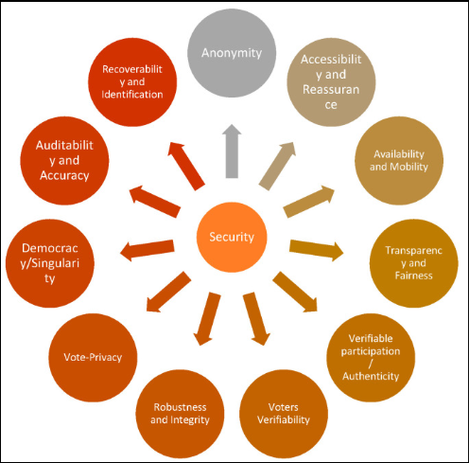

Figure 1: Requirements for E-voting Systems Source: Adapted from [24]

**2.1 The Case for the Utilization of Blockchain Technology in Voting Systems**

Just as it has been mentioned in this study, blockchain has developed potentials for several utilities apart from its use for financial transactions; thus gaining more acceptance in different spheres [25]. Blockchain technology possesses numerous benefits which include its transparency, its integrity, and better placed security over other available systems. Its potential to effectively record and compute election results with lesser probability of any third party tampering or interfering with the process has drastically increased its demand for electioneering process [26]. There are basic concepts within the blockchain technology that are of use and advantage for voting systems and they discuss here in this section of the work;

**Transactions**: transaction refers to the invoking of the particular set of rules to start a contract. For voting systems, enabled with blockchain technology, transactions can include; the votes cast, the result of the elections and other information needed from the voter for verification can also suffice as transactions [27].

**Provenance**: this is the ability of the system to be proven or audited at any point in time, all the participants within the blockchain network can determine the origin of blocks (transactions) and its owner at a given time [28]: therefore, the evaluation of previous transactions is possible in order to further ascertain their history. This matters in electoral processes, because with this feature, all participating voter will be able to confirm whether his/her vote is being counted or not [29].

**Immutability**: immutability is one of the most attractive feature of blockchain technology for voting systems, it simply the ability of blockchain technology that makes it impossible for any transaction to be deleted or edited after it has been added to network. Hence controlling data falsification which is rife within voting systems [30].

**Finality**: this refers to the capability of blockchain technology to secure transactions, as once a transaction is added to the blockchain, there would be no longer be the opportunity to modify it. And all participants across the network must accept and verify the transaction [27].

Very recently, blockchain technology have been deployed to achieve e-voting systems primarily due to their advantages in terms of end-to-end verifiability. With properties such as anonymity, privacy protection and non-repudiation, blockchain is a very attractive alternative to present voting systems especially for the Nigeria the country of study [4].

Figure 1 below illustrates the features of blockchain technology, including some of those not mentioned in this work.

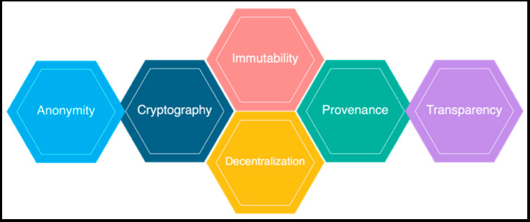

Figure 2 - Features of Blockchain Architecture

Source: Adapted from [24]

The Nigerian voting system has evolved from using the ordinary paper voting systems (PVS). To Modified Open Ballot System, Re-modified Open-secret Ballot System and the system has given birth to the Verification and Accreditation Systems which is being used in conjunction with the Smart Card Reader (SCR) or the (ECR) Electronic Card reader. The Modified Open Ballot was an advanced form of open ballot system referred to as option A4. It entailed the voters queuing openly to cast their votes but with their choices of votes secret [31]. Compared to the option A4, the votes cast in the MOBS are secret while balloting in Option A4 are open. The MOBS approach was utilized in the 1999, 2003 and 2007 General elections. The Re-modified Open-secret Ballot System (ROBS) on the other hand involved the voters getting accredited and their ballot papers being issued openly but then, they cast their votes privately. The ROBS was used in the 2011 General Elections and it basically involved having the voters select their political candidate with their fingerprint on the ballot paper, and cast their vote [32]. It was until the 2015 general elections that a sort of electronic option was included in the form of the Smart Card Reader (SCR) which is basically used to verify the identity of the voters and thereafter authenticating them for the voting process. This was used with the Verification and Accreditation systems [31]. Despite the series of evolution and transformation that the Nigerian voting system has experienced, there are still a lot of contentions with election results as there are still allegations of data mismanagement, falsification and alteration of results to favor particular political parties, rigging and malpractice in general [33]. The challenge have remained unsolved most probably due to some inefficiencies identified within the existing voting system in Nigeria, among which are; security and safety issues, stressful voting time as a result of long hours standing on queues which could be said to have also contributed to voters apathy, rigging of results with the results not reflecting the choice of the majority at times, which further worsens the voter’s apathy situation, etc [34]. It is believed that an adoption and integration of effective technology like the blockchain technology into the voting system of Nigeria will be very beneficial for the country’s democratic process [35].

**3.0 Blockchain framework for Nigerian Voting System**

The current mode of voting (The Paper/Ballot voting) involves a lot of inadequacy and inconsistencies. It is much more susceptible to inaccurate collations and calculations, alterations and untoward modifications. The procedure is also exposed political extortion and manipulation. Hence the reason why it needs to be replaced by a more efficient voting method [36], just like it is illustrated in figure 3 below

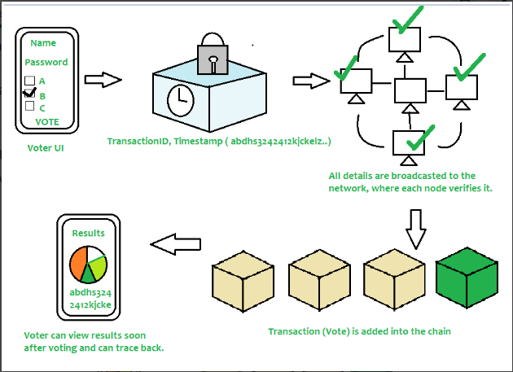

Figure 3- An illustration of Block-chain Voting

Source: Adapted from [3]

Based on the above diagram, the voter will be required to input his/her credentials in order to cast his/her vote, afterwards, the data is then encrypted and stored as a transaction. This transaction is then broadcasted to every node in network, after which its then turn verified. When the network approves transaction, it is then stored and added to chain and as soon as a block is added to the chain, it is there forever as it can’t be updated or modified. And also users are able to trace back each transactions if they want to as the system is very transparent to allow for such [3]. Voting systems created with decentralized technologies like this allow for more credible, free and fair voting process.

Olaniyi et al [37] proposes an e-voting method framework which recommends a multilingual mobile e-voting service structure using major tribes in Nigeria-Yoruba, Igbo and Hausa. The framework identifies the series actions carried out in the pre-election, and post-election stages which allowe the voters to cast their vote from anywhere using their mobile phones. While the votes are being submitted into a repository or database to tally the votes. Figure 4 below illustrates how the framework works.

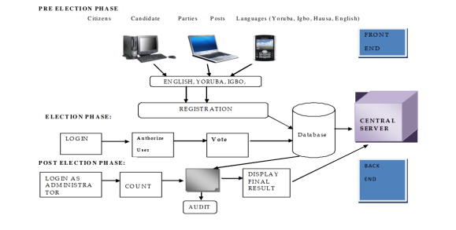

Figure 4: proposed service-oriented mobile e-voting framework

Source: Adapted from [37]

However, the challenge with this proposed e-voting framework as much as it allows for voters to vote from anywhere with their mobile phones which would encourage more voters to participate more in the voting process, it still has a centralized database and server which is susceptible to malicious attack from hackers and it is also susceptible to internal alterations and manipulations. Therefore, while it encourages voter’s participation, it is still lacking in the aspect of credibility and integrity. Hence the need for an improved mobile e-voting framework built on the blockchain technology.

**3.0.1 Proposed Improved Framework**

This proposed improved framework is adopted from Abayomi-Zannu et al, whose framework is also adapted from the above framework in figure 3 [38]. The model utilized the three phases from the adapted framework by Olaniyi et al, namely the pre-election phase, the election phase and the post -election phase. It also made use of a database that voter’s identification number (VIN) and other important data was sent to. However, it included a distributed blockchain database and a multi-factor authentication to verify the voters which include their voter’s identification number (VIN), PIN and one-time password (OTP). The figure 5 below illustrates the proposed improved framework.

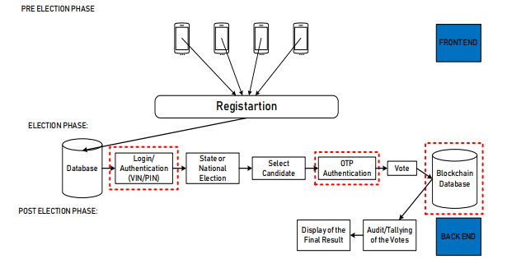

Figure 5: Proposed Improved Blockchain Technology E-voting Framework.

Source: Adapted from [38]

The voting system allows for the registration of eligible voters with their mobile device and the information is stored in a database through which login and authentication process will be provided for eligible voters alone by using the two-factor authentication, voter’s identification number (VIN), personal identification number (PIN), and one-time password (OTP). This is to ensure only eligible registered voters are allowed access to the voting platform. Thereafter the votes are casted with each vote being uniquely encrypted and securely stored in the blockchain database from which tallying and the final display of result is carried out. The proposed framework is divided into the Front end layer and the Backend layer

1. Front End Layer: The front end layer is categorized into two phases namely: the pre-election phase and the election phase. In the pre-election phase, voters register themselves and their data is stored in the voter’s database and in the election phase is where the actual voting is done with voters using their mobile devices to cast their votes. The votes are stored in the blockchain database which cannot be tampered with.
2. Back End Layer: The backend layer deals with the blockchain database that can be viewed and monitored by the electoral management board. The activities here are usually carried out after the election i.e. post-election. At this point the votes stored in the blockchain database would be tallied and the result would be presented.

It is expected that this framework would aid in improving the overall efficiency of voting processes thereby helping the course of democracy and credibility of electoral process in the country. The figure 6 below further illustrates all the steps involved using the proposed blockchain system in its three stage process rendition.

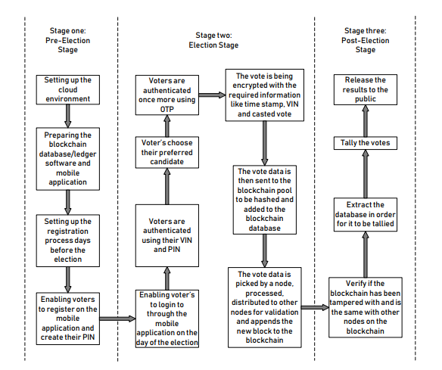

Figure 6: Scheme of Proposed framework

Source**:** Adapted from [38]

Some benefits that can be gotten if this system is effectively deployed are:

* There would be no need to set up polling units on the day of election since the voters would only be required to log in on their mobile phones to cast their votes. Hence cutting down cost of conducting elections by a large margin
* Voters would not be required to leave their homes to stand on queues before they can cast their votes.
* Multiple voters who might have been dis-enfranchised because of disabilities or being elderly and being unable to stand on queue for a long time will be able to cast their votes more conveniently.
* Security problems erstwhile related with elections will be more or less inexistent.
* Government would not need to forfeit a productive day for the elections as people won’t have to stay at home because of elections. They can easily be at work and take some time out to cast their votes and get back to work [38].

**3.1 PESTLE ANALYSIS**

This study employs the PESTELE analysis to examine key external factors i.e. the Political, Economic, Social, Technological, Legal and Environmental factors that can influence and also challenge the use of blockchain technology for the voting system in Nigeria [39].

**3.1.1 Political**

**Policies**- The government of Nigeria has albeit slowly but surely has begun to embrace blockchain technology, this is especially seen with its development of the e-naira a blockchain supported currency for financial transaction [40]. Also, the government has established an e-government project as a part of its efforts to ensure the effective and efficient transformation of the country’s technological compliance with new technologies like blockchain technology for instance. Furthermore, the electoral body (INEC) is poised to adopt the technology with its history of deploying technological alternatives to electoral processes in the country [21].

**CBN Restrictions**

The restrictions of the central bank on blockchain supported currencies however raises concerns as to whether the government will adopt the technology for the country’s electoral process,

**Institutionalized Corruption**

There is the lack of political will on the part of the political class to adopt the new technology considering its potential to ensure freer and fairer elections that may not be easily manipulated to their benefits hence slow / stagnant proceeding towards the consequent adoption.

**3.1.2 Economic**

**Cost Efficiency**

The utilization of Blockchain technology for voting systems will substantially cut down on the cost of elections which as at 2019 elections gulped up to 242 billion Naira while up to 305 billion Naira is being projected to be spent in the coming 2023 elections [41]. Furthermore, the existing pool of available labour force in the form of the NYSC youth corps members that has a major number of them savvy enough or ready to learn quickly to operate the developed Blockchain systems and help cut cost.

**Security**

The prevalent insecurity within the country also has a crippling effects on the country’s economy and negatively affects the investment capacity of the country in new technology for its voting system. Adopting blockchain technology will ensure a secure avenue for voters to execrcise their franchise from the convenience of their homes without fear of being molested on the election day Hence, leaving no room for the nascent violence that has rocked Nigeria elections in the past [5].

**3.1.3 Social**

The use of blockchain technology in the Nigerian voting system will improve the trust level of the electorate in the voting process therefore reducing voter’s apathy.

**Convenience** – The use of the blockchain technology creates convenience for voters during the voting process which erstwhile has been very stressful and required going through tedious processes before voting. This will trigger increased participation in elections and result in a more representative electoral process.

**Technology literacy** – Due to various reasons like poor education, inadequate or lack of technological infrastructure, and religious beliefs, the computer literacy level in Nigeria is very low and this could adversely affect the effectiveness of the utilization of blockchain technology for electoral processes in the country.

**3.1.4 Technological**

**Exposure to cyber attacks**

Cyber attacks such as DDoS attacks could be launched against the voting system and significantly hamper its effectiveness and compromising system integrity, considering the unregulated and porous computing space in the country. Although the transparent and decentralised nature of blockchain technology enables such attacks to be easily noticeable and singled out. It is recommended that pilot tests be carried out sort out possible deficiencies and strengthen the defense of the system before full launch.

**3.1.5 Legal**

**Legal Support** – There’s is the need for solid legal backing for the system a well defined legal framework will influence a mass adoption and support for the system by relevant government bodies.

The anonymity of the blockchain technology is one of the major selling point for individuals with malicious or criminal intentions seeking to mask their identity. And as it is known that, Nigeria presently is home to a high number of cybercriminals and cybercrime is increase on a daily basis in the country [42]. There is a high possibility that the system might be hijacked or covertly subverted. However, as at present the current legal framework is still too weak to enact cyber security laws hence the dilemma for the potential development of the blockchain technology in the country, until the legal system is able to expand its capacity to meet up with its responsibility.

**3.1.6 Environmental**

The deployment of the blockchain technology eliminates the need for paper voting, paper is gotten from trees and trees have to be cut down to manufacture paper, the elimination of the need for paper, directly helps the environment and also engenders sustainable development and therefore is encouraged as the form of voting that can help protect the environment [43]

The computational power for the blockchain system however requires a lot of power to operate and based on its massive consumption of energy might potentially be contributing to the global warming situation hence affecting the environment negatively [44]. Moreover renewable energy systems could be deployed to power up the technology and help reduce it adverse effect on the environment to a minimum.

**4.0 Forecasted Challenges for Blockchain Empowered Voting (BEV) in Nigeria**

The block-chain technology is one of the most radical and disruptive technological advances in the recent times. However, despite its attractiveness for case use, there are several concerns pertaining to blockchain technology. The following are some challenges faced by blockchain technology.

* Set up Cost- To set up a blockchain technology is quite expensive as it needs to incorporate software cost and the need for the qualified personnel expertise.
* Integration with Legacy Systems- Transitioning to a blockchain based system is achieved by either rebuilding the entire system or by fusing with the existing system. It is not quite easy to totally eradicate legacy or existing systems that have already been entrenched and adapted to, thus the feasible solution would be to make changes to an existing system that can support blockchain technology [45].
* Energy Consumption- Validating transactions on blockchain requires computing complex mathematical algorithms for transaction verification and network security. And these computations consume a lot of power and energy. Hence sustainable generation of energy is needed to support the technology

* Complexity- The technology is based on new vocabulary which has and incorporates several of its own unique jargons. Thus people need to be well acquainted with it to operate it effectively.
* Possibility of human error- There needs to be accurate input of data because the system keeps the data sent in to it and after verification such block may not be available for modification any longer. Hence the need for accurate recording, because at times not all information available on the system may be regarded as reliable because of human error.

**5.0 Conclusion**

In this work, the possibility of utilizing blockchain technology for voting systems for Nigeria was evaluated. The essence of the adoption of the technology was to improve the democratic process of voting and ensure that discrepancies existent in the existing voting systems are removed hence aiding in better response from voters, reducing voter’s apathy and strengthening the country’s democracy. The features of the blockchain technology were leveraged upon in order to achieve these objectives. The proposed approach is to encourage an e-voting system built with blockchain database that will ensure the storage bank is decentralized and thus is less exposed to manipulations and data alterations that has plagued the existing voting system. The proposed harmonization of mobile devices, blockchain technology, and multi-factor authentication is believed to greatly enhance and simplify the voting process in Nigeria while also providing better transparency that can regain voters trust and reduce voter’s apathy.

**References**

[1] T. Laurence, *Introduction to blockchain technology: The many faces of blockchain technology in the 21st century*. Hertogenbosch: Van Haren Publishing, 2019

[2] I. Priyadarshini, “INTRODUCTION TO BLOCKCHAIN TECHNOLOGY” in *CYBERSECURITY IN PARALLEL AND DISTRIBUTED COMPUTING*, Dac-Nhuong Le et al Eds. Beverly: Scrivener Publishing. 2018, pp 85-97

[3] Geekforgeeks . (2022, Aug, 03). *Decentralized Voting System using Block-chain* [online]. Available: https://www.geeksforgeeks.org/decentralized-voting-system-using-blockchain/

[4] K.M Khan , J. Arshad , M. M. Khan (2018, May 1). *Secure Digital Voting System based on Blockchain Technology* [online] Available:https://core.ac.uk/display/155779036?utm_source=pdf&utm_medium=banner&utm_campaign=pdf-decoration-v1 DOI:10.4018/IJEGR.2018010103

[5] E. M. Dogo , N. I. Nwulu , O. M. Olaniyi , C. O. Aigbavboa , and T. Nkonyana (2018). “Blockchain 3.0: Towards a Secure Ballotcoin Democracy through a Digitized Public Ledger in Developing Countries” in *Conf. 2 nd International Conference on Information and Communication Technology and Its Applications (ICTA 2018)*. Federal University of Technology, Minna, Nigeria September 5 – 6.

[6] A. Falade, A. A. Adebiyi, C. K. Ayo, M. Adebiyi, and O. Okesola. “E-voting system: the pathway to free and fair election in Nigeria”, *Electron. Gov*. an Int. J., vol. 15, no. 4, p. 439, 2019.

[7] U. Madise and T. Martens, -E-voting in Estonia 2005. The first practice of country-wide binding Internet voting in the world, ‖ Electron. Voting 2006 - 2nd Int. Work., no. October, pp. 15–26, 2006.

[8] A. Falade, A. A. Adebiyi, C. K. Ayo, M. Adebiyi, and O. Okesola, “E-voting system: the pathway to free and fair election in Nigeria”, *Electron. Gov*. an Int. J., vol. 15, no. 4, p. 439, 2019.

[9] J. Gerlach and U. Gasser, -Three Case Studies from Switzerland : E-Voting, 2009

[10] M. J. Kripp and C. Bull, 5th International Conference on Electronic Voting 2012 (EVOTE2012) : July 11-14, 2012, Castle Hofen, Bregenz, Austria. Ges. f r Informatik, 2012.

[11] M.D.R Ahmed, F.M Shamrat, M. D Ali, M.D Rajib Mia, M.S.T Khatun. The Future of Electronic Voting System Using Blockchain. INTERNATIONAL JOURNAL OF SCIENTIFIC & TECHNOLOGY RESEARCH VOLUME 9, ISSUE 02, FEBRUARY 2020. ISSN 2277-8616

[12] R. Cullen and C. Houghton, ―Democracy online: an assessment of New Zealand government web sites, Gov. Inf. Q., vol. 17, no. 3, pp. 243–267, Jul. 2000.

[13] A. Basiru and K. Adesina. “Electoral reforms and the administration of the 2015 general elections in Nigeria.” Democracy and Security, 15(3):207–229, 2019.

[14] K. Animashaun. Regime character, electoral crisis and prospects of electoral reform in nigeria. Journal of Nigeria Studies, 1(1).2010

[15] A.S Adesote and J.O. Abimbola. Electoral violence and the survival of democracy in nigeria’s fourth republic: A historical perspective. Canadian Social Science, 10(3):140–148.2014

[16] O. Olakunle, R. Bamidele, A. Modupe, O. Oluwaseun, and A. Magdalene. Trends in electoral violence in nigeria. Journal of Social Sciences and Public Policy, 11(1):37–52, 2019

[17] J. Wu and N.K. Tran. “Application of blockchain technology in sustainable energy systems: An overview”. *Sustainability*, *10*(9), p.3067.2018

[18] W. Viriyasitavat, and D. Hoonsopon. “Blockchain characteristics and consensus in modern business processes”. *Journal of Industrial Information Integration*, *13*, pp.32-39.2019

[19] S. Seebacher, and R. Schüritz, R. “Blockchain technology as an enabler of service systems: A structured literature review”. In *Conf* *International conference on exploring services science* (pp. 12-23). Springer, Cham.2017

[20] Gobel, J., Keeler, H. P., Krzesinski, A.E. and Taylor, P.G. (2015). Bitcoin Blockchain Dynamics: the Selfish-Mine Strategy in the Presence of Propagation Delay, May 2015.

[21] Multichain (2017) Open platform for blockchain applications. Available at: www.multichain.com last accessed: December 2017.

[22] Dalia, K., Ben, R., Peter Y. A, and Feng, H. (2012) A fair and robust voting system by broadcast, 5th International Conference on E-voting, 2012.

[23] Rura L., Issac B., and Haldar M. K. (2016) Implementation and evaluation of steganography based online voting, International Journal of Electronic Government Research.

[24] U. Jafar, M.J.A Aziz, Z. Shukur . Blockchain for Electronic Voting System-Review and Open Research Challenges. Sensors (Basel). 2021 Aug 31;21(17):5874. doi: 10.3390/s21175874. PMID: 34502764; PMCID: PMC8434614.

[25] Ahmed Kosba, Andrew Miller, Elaine Shi, Zikai Wen, and Charalampos Papamanthou. Hawk: The blockchain model of cryptography and privacy-preserving smart contracts. In 2016 IEEE symposium on security and privacy (SP), pages 839–858. IEEE, 2016.

[26] Pavel Tarasov and Hitesh Tewari. The future of e-voting. IADIS International Journal on Computer Science & Information Systems, 12(2), 2017.

[27] J. Pratt, N. Bradley, E. Zavesky, N. Marathe, and T. Innes. “Blockchain based information management”, December 19 2019. US Patent App. 16/007,747

[28] S.A McKinney, R. Landy, and R. Wilka. “Smart contracts, blockchain, and the next frontier of transactional law”. *Wash. JL Tech. & Arts*, 13:313, 2017.

[29] R. Herian. *Regulating blockchain*: Critical perspectives in law and technology. Routledge, 2018.

[30] F. Hjalmarsson, G.K Hreidarsson, M. Hamdaqa, and G. Hjalmtysson. ` Blockchain-based e-voting system. In *Conf 2018 IEEE 11th International Conference on Cloud Computing* (CLOUD), pages 983–986. IEEE, 2018.

[31] A.O Esan and T.B Ayeni. E-voting in nigeria: Barriers to full implementation. Ahmadu Bello University, 2017

[32] O. Okediran, E. Omidiora, S. Olabiyisi, G. Adesina, and S. Adeyemi. Towards remote electronic voting systems. Computer Engineering and Intelligent Systems, 2, 07 2011.

[33] G. Ihemeje. Election, international election monitoring groups and Nigeria’s fourth republic. Journal of Arts and Humanities, 8(11):54–62, 2019.

[34] B .O Emmanuel. Presidential elections and electoral violence. 2020.

[35] A. Wilhelm. “Blockchain technology and the development of african economies: Promises, opportunities, and the legal issues at stake.” RiA Recht in Afrika| Law in Africa| Droit en Afrique, 22(1):3–42, 2019.

[36] Gentles, D., Sankaranarayanan, S.: Biometric secured mobile voting. In: 2nd Asian Himalayas International Conference on Internet (AH-ICI), pp. 1–6. IEEE, New Jersey (2011)

[37] O. M. Olaniyi, D. O. Adewumi, , Oluwatosin , E. A Arulogun,, & M. A. Bashorun, (2011). Framework for Multilingual Mobile E-Voting Service Infrastructure for Democratic Governance. African Journal of Computing and ICT (Journal of IEEE Nigeria Computer Section), 4(3), 23–32. Retrieved from https://www.academia.edu/3716839/Framework_for_Multilingual_Mobile_E-voting_Service_Infrastructure_for_Democratic_Governance?auto=download

[38] Abayomi-Zannu et al. A Proposed Mobile Voting Framework Utilizing Blockchain Technology and Multi-Factor Authentication. J. Phys.: Conf. Ser. 1378 032104

[39] K. Peterdy. (2022). *PESTEL Analysis*. [online]. Available: https://corporatefinanceinstitute.com/resources/management/pestel-analysis/

[40] S. Kedem (2021). *Nigeria launches eNaira – Africa’s first digital currency*. [online]. Available : https://african.business/2021/10/finance-services/nigeria-gears-up-for-enaira/

[41] N. Dazang (2022). *Understanding the high cost of elections*. [online]. Available: https://guardian.ng/opinion/understanding-the-high-cost-of-elections/

[42] Statista.(2022). *Mobile internet user penetration in Nigeria from 2018 to 2027*.[online].Available: https://www.statista.com/statistics/972900/internet-user-reach-nigeria/

[43] Business Day (2022). *Nigeria recorded a 174% increase in cybercrimes in six months, here’s why you should be bothered*.[online].Available : https://businessday.ng/news/article/nigeria-recorded-a-174-increase-in-cybercrimes-in-six-months-heres-why-you-should-be-bothered/

[44] N. Belk. (2017). *Electronic voting makes polls environmentally friendly and more reliable*. [online]. Available: https://dailytitan.com/opinion/electronic-voting-makes-polls-environmentally-friendly-and-more-reliable/article_59886739-caf3-50f4-bccc-b55a70d921fc.html

[45] J. Sedlmeir, H.U. Buhl, G. Fridgen. The Energy Consumption of Blockchain Technology: Beyond Myth. *Bus Inf Syst Eng* **62**, 599–608 (2020). https://doi.org/10.1007/s12599-020-00656-x

[46] K.West *et al*, “Do you need a Blockchain?”, Department of Computer Science ETH, International Association for Cryptologic Research, 2017.